**PRACTICAL: 5**

**AIM:** Create a login application with following features:

1. Successful Login message in TextView with Green background if

Username & password is correct

2. Failure message in TextView with Red background if Username or

password is incorrect.

3. Disable Login Button after three wrong login attempts.

4. Close application if user selects Cancel Button.

**THEORY:**

* AlphaAnimation: java.lang.Object

↳ android.view.animation.Animation

↳ android.view.animation.AlphaAnimation

* + An animation that controls the alpha level of an object. Useful for fading things in and out. This animation ends up changing the alpha property of a Transformation.
  + Methods (Constructor):
    - AlphaAnimation(Context context, AttributeSet attrs)

Constructor used when an AlphaAnimation is loaded from a resource.

* + - AlphaAnimation(float fromAlpha, float toAlpha)

Constructor to use when building an AlphaAnimation from code.

* Count down timer as simple as we see in watches and mobile phones. we can set count down time after completion of time it will stop and get 0 values.

There are four methods are available to use countdown timer as shown below -

* + **onTick(long millisUntilFinished )** - In this method we have to pass countdown mill seconds after done countdown it will stop Ticking.
  + **onFinish()** - After finish ticking, if you want to call any methods or callbacks we can do in onFinish().
  + **start()** - It is used to call countdown timer.
  + **cancel()** - It is used to cancel countdown timer.
* Other:
  + setEnabled(): It is used to enable or disabled particular component.
  + requestFocus(): It used to move curser to another EditText Field.

**CODE:**

|  |
| --- |
| **MainActivity.java**  package com.example.pr5_login;  import android.annotation.SuppressLint;  import android.os.Bundle;  import android.app.Activity;  import android.graphics.Color;  import android.view.View;  import android.view.animation.AlphaAnimation;  import android.widget.Button;  import android.widget.EditText;  import android.widget.TextView;  import android.widget.Toast;  import android.os.CountDownTimer;  public class MainActivity extends Activity {  Button b1,b2;  EditText ed1,ed2;  TextView tx2,tx4;  int counter = 3;  private AlphaAnimation buttonClick= new AlphaAnimation(0.2F,1.0F);  @Override  protected void onCreate(Bundle savedInstanceState) {  super.onCreate(savedInstanceState);  setContentView(R.layout.activity_main);  b1=(Button)findViewById(R.id.button);  ed1=(EditText)findViewById(R.id.editText1);  ed2=(EditText)findViewById(R.id.editText2);  b2=(Button)findViewById(R.id.button2);  tx2=(TextView)findViewById(R.id.textView4);  b1.setOnClickListener(new View.OnClickListener() {  @SuppressLint("SetTextI18n")  @Override  public void onClick(View v) {  buttonClick.setDuration(100);  buttonClick.setStartOffset(75);  buttonClick.setFillAfter(true);  v.startAnimation(buttonClick);  if(ed1.getText().toString().equals("Raj") &&  ed2.getText().toString().equals("raj")) {  Toast.makeText(getApplicationContext(), "Authentication Successful",Toast.LENGTH_SHORT).show();  tx2.setVisibility(View.VISIBLE);  tx2.setBackgroundColor(Color.GREEN);  tx2.setText("Login Successful");  }  else{  counter--;  Toast.makeText(getApplicationContext(), "Attempt left:"+counter,Toast.LENGTH_SHORT).show();  ed2.setText(null);  tx2.setVisibility(View.VISIBLE);  tx2.setBackgroundColor(Color.RED);  tx2.setText("Error:Username or Password is incorrect." +  " Try Agian");  if (counter == 0) {  counter=3;  new CountDownTimer(15000, 1000) {  public void onTick(long millisUntilFinished) {  ed1.setText(null);ed1.setEnabled(false);  ed2.setText(null);ed2.setEnabled(false);  b1.setEnabled(false);  b1.setBackgroundColor(Color.argb(150,103,58,183));  b1.setText( millisUntilFinished / 1000+"s");  tx2.setText("You have entered wrong credentials 3 times,Try after 15s.");  }  public void onFinish() {  ed2.setEnabled(true);  ed1.setEnabled(true);  ed1.requestFocus();  b1.setEnabled(true);  b1.setText("LOGIN");  b1.setBackgroundColor(Color.rgb(103,58,183));  tx2.setBackgroundColor(Color.YELLOW);  tx2.setText("Give it another shot");  }  }.start();  }  }  }  });  b2.setOnClickListener(new View.OnClickListener() {  @Override  public void onClick(View v) {  finish();  buttonClick.setDuration(100);  buttonClick.setStartOffset(75);  buttonClick.setFillAfter(true);  v.startAnimation(buttonClick);  }  });  }  }  **activity_main.xml**  <?xml version="1.0" encoding="utf-8"?>  <RelativeLayout xmlns:android="http://schemas.android.com/apk/res/android"  xmlns:tools="http://schemas.android.com/tools"  android:layout_width="match_parent"  android:layout_height="match_parent"  android:background="#75673AB7"  tools:context="com.example.pr5_login.MainActivity">  <TextView  android:id="@+id/textview"  android:layout_width="match_parent"  android:layout_height="56dp"  android:layout_alignParentTop="true"  android:layout_centerHorizontal="true"  android:background="#673AB7"  android:paddingHorizontal="10dp"  android:paddingVertical="10dp"  android:text="Login(17IT008)"  android:textColor="#FFFFFF"  android:textSize="24sp"  android:textStyle="bold" />  <TextView  android:id="@+id/textView1"  android:layout_width="match_parent"  android:layout_height="wrap_content"  android:layout_below="@+id/textview"  android:layout_centerHorizontal="true"  android:background="#9932C5BF"  android:textAlignment="center"  android:textColor="#ea320d"  android:textSize="35dp"  android:visibility="invisible" />  <EditText  android:id="@+id/editText1"  android:layout_width="wrap_content"  android:layout_height="wrap_content"  android:layout_below="@+id/textView1"  android:layout_alignParentStart="true"  android:layout_alignParentLeft="true"  android:layout_alignParentEnd="true"  android:layout_alignParentRight="true"  android:layout_marginTop="46dp"  android:focusable="true"  android:hint="Username"  android:textColorHighlight="#304ffe"  android:textColorHint="#66304FFE" />  <EditText  android:id="@+id/editText2"  android:layout_width="wrap_content"  android:layout_height="wrap_content"  android:layout_below="@+id/editText1"  android:layout_alignEnd="@+id/editText1"  android:layout_alignRight="@+id/editText1"  android:layout_alignParentStart="true"  android:layout_alignParentLeft="true"  android:ems="10"  android:hint="Password"  android:inputType="textPassword"  android:textColorHint="#66304FFE" />  <TextView  android:id="@+id/textView2"  android:layout_width="wrap_content"  android:layout_height="wrap_content"  android:layout_below="@+id/editText2"  android:layout_alignParentStart="true"  android:layout_alignParentLeft="true"  android:text="Attempts Left:"  android:textSize="25dp"  android:visibility="invisible" />  <Button  android:id="@+id/button"  style="@android:style/Widget.DeviceDefault.Button"  android:layout_width="wrap_content"  android:layout_height="wrap_content"  android:layout_below="@+id/textView2"  android:layout_alignEnd="@+id/textView2"  android:background="#673AB7"  android:text="LOGIN"  android:textAllCaps="false"  android:textColor="#FFFFFF" />  <Button  android:id="@+id/button2"  style="@style/Widget.AppCompat.Button"  android:layout_width="wrap_content"  android:layout_height="wrap_content"  android:layout_alignTop="@+id/button"  android:layout_marginLeft="10dp"  android:layout_toEndOf="@+id/button"  android:background="#673AB7"  android:text="Cancel"  android:textColor="#FFFFFF" />  <TextView  android:id="@+id/textView4"  android:layout_width="wrap_content"  android:layout_height="wrap_content"  android:layout_below="@+id/button"  android:layout_centerHorizontal="true"  android:layout_marginTop="10dp"  android:text="Result"  android:textAppearance="?android:attr/textAppearanceLarge" />  </RelativeLayout>  **AndroidManifest.xml**  <?xml version="1.0" encoding="utf-8"?>  <manifest xmlns:android="http://schemas.android.com/apk/res/android"  package="com.example.pr5_login">  <application  android:allowBackup="true"  android:icon="@mipmap/ic_launcher"  android:label="@string/app_name"  android:roundIcon="@mipmap/ic_launcher_round"  android:supportsRtl="true"  android:theme="@style/Theme.AppCompat.DayNight.DarkActionBar">  <activity android:name=".MainActivity">  <intent-filter>  <action android:name="android.intent.action.MAIN" />  <category android:name="android.intent.category.LAUNCHER" />  </intent-filter>  </activity>  </application>  </manifest> |

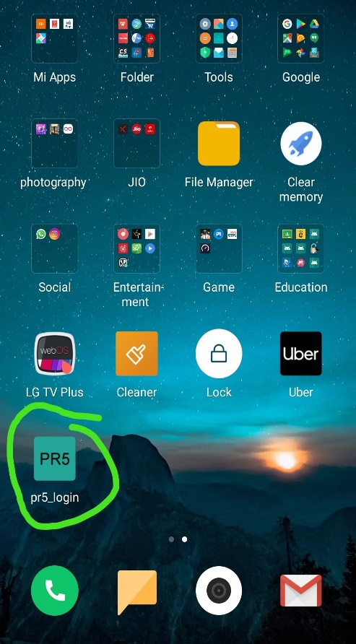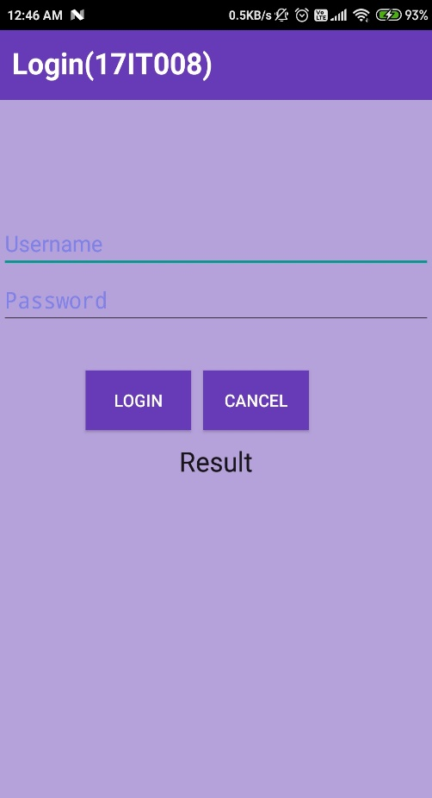**OUTPUT:**

ScreenShot 1

ScreenShot 2

ScreenShot 2

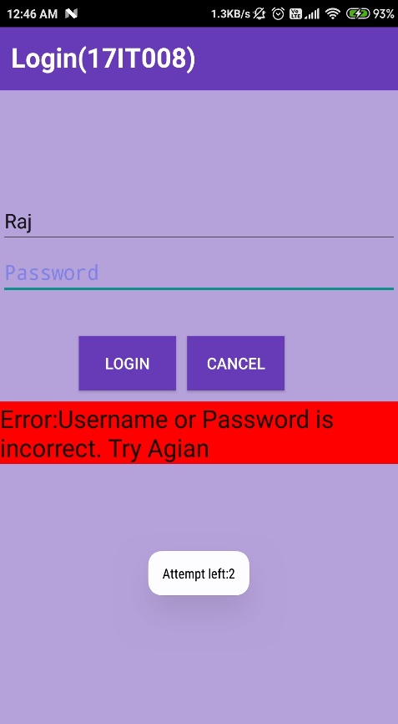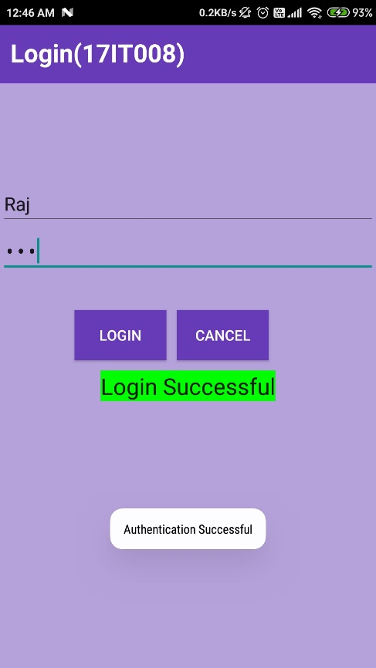

ScreenShot 4

ScreenShot 3

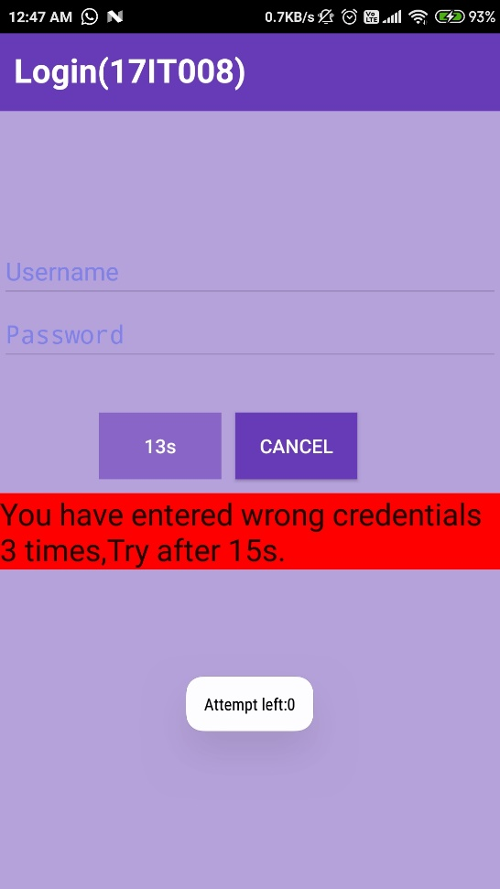 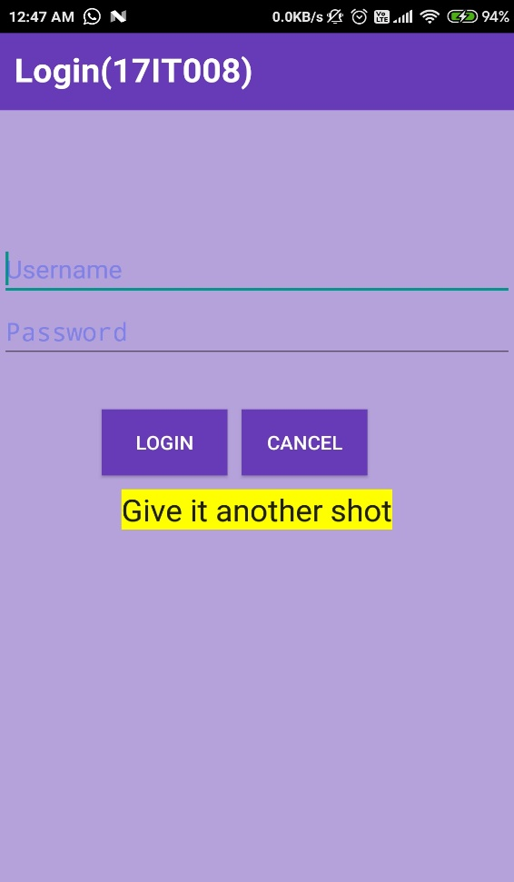

ScreenShot 5 ScreenShot 6

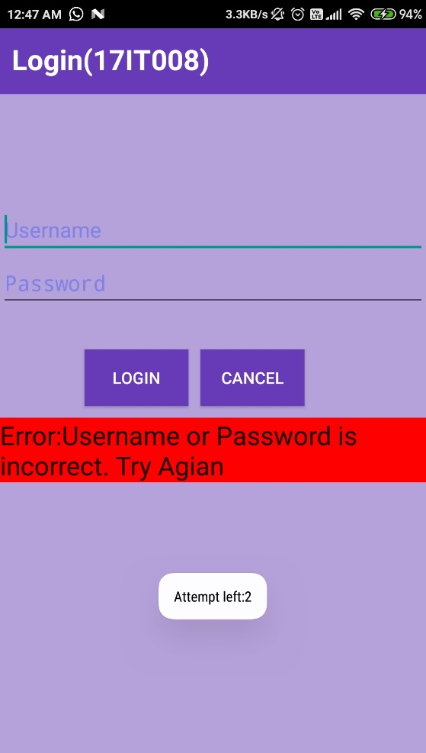

ScreenShot 7

**Description**:

* Screenshot 1: In First We can see the **change in default icon** of the application.
* Screenshot 2: It shows the **mainactivity** of the app.
* Screenshot 3: when user will enter **correct credentials**, it will show output as shown in image.
* Screenshot 4: When user will enter **wrong credentials**, it will **reset the password field** and show the error as well as the **amount of remaining attempt** via toast as shown.
* Screenshot 5: When user will enter wrong credentials for **three consecutive time** it will **disable** the **fields** (Username, Password) and the **login button** at that time **15sec timer** will start.
* Screenshot 6,7: After 15 seconds the disabled components will be **enabled** and user can enter will be given **three more attempts**.

**APPLICATIONS:**

Android Studio, ADB (Android Debug Bridge), AVD Manager, Eclipse, Fabric, Genymotion,

**LEARNING OUTCOME:**

1.We learn how to **change the app icon** by taking image and vector.

2.We learned how to **disable the particular components and also used the 3rd practical’s timer concept** for better efficiency in app.

3. We learned how to add animations to button by using **AlphaAnimation.**

4. We learned to use **requestFocus()** method to **move** the cursor to **Usernam**e field after 15sec.